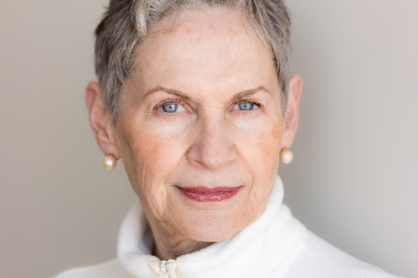
___________________________’s One Page Profile
What people like and admire about___________ __about_______
aaboutabout_______
What is Important for __________________
Important To _________________

Additional Information about____________________

Adapted from The Learning Community for Person Centered Practices (www.tlcpcp.com 2016) by Anastasia Edmonston MS CRC 2020
We all have a passion for helping people with brain injury: Tell Us about Your Skills and Passion
What specifically is important to you about being on this council?

Can you describe what types of skills you use in your current job and what you might be able to bring to the council?

What do you consider to be your strengths that you can contribute to the council?

What are two specific things you want to help the council achieve?

What types of initiatives/roles do you excel at?

How do you define success?

How do you see yourself contributing to committee work?

Just for fun – is there anything in your personal life that you might like to share with the council? (For example – getting married, celebrating an achievement, or your hobbies?)

