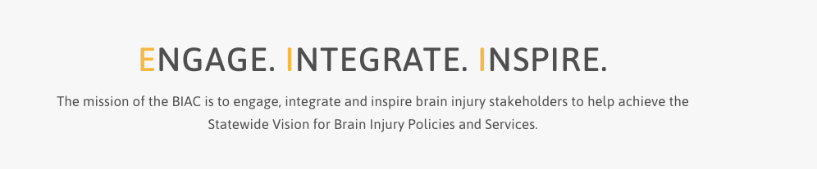

**Brain Injury Advisory Council (BIAC) Meeting**

**December 13, 2024 - 10:00 a.m. – 2:00 p.m. CT**

**Zoom information for connecting:** <https://educationne.zoom.us/j/94166263913>

     To Join By Phone, dial +1 312 626 6799 US (Chicago) - Meeting ID: 941 6626 3913

Find your local number: [https://educationne.zoom.us/u/avQempuQZ](https://gcc02.safelinks.protection.outlook.com/?url=https%3A%2F%2Feducationne.zoom.us%2Fu%2FavQempuQZ&data=04%7C01%7Ctresa.christensen%40nebraska.gov%7C8eda94b598aa45b8998c08d8de701be1%7C043207dfe6894bf6902001038f11f0b1%7C0%7C0%7C637503921589608306%7CUnknown%7CTWFpbGZsb3d8eyJWIjoiMC4wLjAwMDAiLCJQIjoiV2luMzIiLCJBTiI6Ik1haWwiLCJXVCI6Mn0%3D%7C1000&sdata=T9GyKObyOhtXev7WvsMZvUHeowOIFrkAK9DKWLQkB0s%3D&reserved=0)

**AGENDA**

**10:00 – 10:15 am:** ***ENGAGE***

**Call the meeting to order – *Judy Nichelson***

*Please enter your name in the chat box so the Recorder can take attendance and determine a quorum. We ask that you join the meeting with your camera on if possible, and keep your microphone or telephone muted if you’re not speaking to reduce background noise.*

**Introductions*****– Judy Nichelson and all members***

*Judy will introduce our new members, Jennifer Swanson and Lisa Kent-Scheer, and all members will briefly introduce themselves.*

**Approve September 13, 2024 meeting minutes and December 13, 2024 meeting agenda – *Judy Nichelson***

*BIAC members, please read the past meeting minutes and the new agenda before the meeting and be prepared to offer any corrections to the minutes or additions to the agenda if needed. Vote to approve.*

**10:15 – 10:55 am: *ENGAGE and INTEGRATE***

**2024 Brain Injury Needs Assessment Report Part 1–*Liz Gebhart-Morgan of Partners for Insightful Evaluation (PIE)***

*We will break this topic into three parts; 1. Individuals with brain injury, 2. Family Members and Informal Caregivers and 3. Service Providers. For each part, Liz will have 10 minutes to present the data then we’ll join breakout rooms for 15 minutes for small group discussion. Please choose a person in your group to take notes. Each group will then report out to the large group. The small group discussion questions are: Based on the data you just heard, 1. What seems to be going well? 2. What gaps or barriers are still a concern?*

**10:55 – 11:05 am – Break**

**11:05 – 11:45 am: *ENGAGE and INTEGRATE***

**2024 Brain Injury Needs Assessment Report Part 2 *- Family Members and Informal Caregivers***

*Data presentation, small group discussion, report out. The small group discussion questions are: Based on the data you just heard, 1. What seems to be going well? 2. What gaps or barriers are still a concern?*

**11:45 am – 12:05 pm:**

**Working Lunch**

*Break for lunch for 20 minutes. Please feel free to bring your meal back to the meeting as we continue to work through our agenda.*

**12:05 – 12:45 pm: *ENGAGE and INTEGRATE***

**2024 Brain Injury Needs Assessment Report Part 3 *- Service Providers***

*Data presentation, small group discussion, report out, plus wrap up and next steps. The small group discussion questions are: Based on the data you just heard, 1. What seems to be going well? 2. What gaps or barriers are still a concern?*

**12:45 – 1:00 pm: *INSPIRE***

**Final Brain Injury + COVID-19 literature review - *Keri Bennett and Liz Gebhart-Morgan of Partners for Insightful Evaluation (PIE)***

*Keri and Liz will share the reports and products from our TBI Public Health supplemental grant project with PIE. No member action is needed, but there will be time for questions.*

**1:00 – 1:15 pm - Updates: *ENGAGE and INSPIRE***

**Committee and Contractor Reports (written reports)**

*Please read the written reports and be prepared with any questions or comments for the Committee Chairpersons.*

**Public Policy – *No Report***

**Membership** *–* ***Carla Lasley***

**Contractor reports and ACL Workgroup Updates (written reports only) – *Keri Bennett***

*Please review the written reports. No member action is needed, but there will be time for questions.*

**1:15 – 1:30**: ***ENGAGE***

**New Chair Appointment and Vice Chair Election – *Keri Bennett and Carla Lasley***

*Candidates for Vice Chair will have an opportunity to speak before members vote by anonymous poll.*

**1:30 – 1:45 pm: *ENGAGE and INSPIRE***

**Recent Federal News and Initiatives**

**BIAA & NASHIA Brain Injury Awareness and Advocacy** – ***Keri Bennett***

*Keri will share events planned in Washington, DC, March 3 – 6, 2025.*

**Report on the September 2024 NASHIA conference** – ***Keri Bennett and Karen Houseman***

*Keri and Karen will share their take-aways from the NASHIA conference.*

**1:45 pm – 2:00 pm: ENGAGE**

**Set 2025 Meeting Dates: *All Members***

**Proposed dates are: March 28, June 13, September 19, and December 12**

*All dates are Fridays. Meetings will be scheduled from 10:00 am – 2:00 pm and will be held via Zoom unless otherwise indicated.*

**Roundtable Discussion:** ***All Members***

**Unfinished (Old) Business** (if any)

*If there are questions regarding past BIAC business items that were unresolved, you may raise them here.*

**New Business** (if any)

*If you have a new topic or issue you believe the BIAC should consider, you may raise it here and request it be added to a future meeting agenda.*

**Adjourn – Please complete our survey at the end of the meeting. Your feedback helps the BIAC leadership continue to improve your member experience. Thank you!**

**Feel free to stay on for the “Parking Lot” after the meeting adjourns!**

**Next Meeting Date**: March 28, 2025