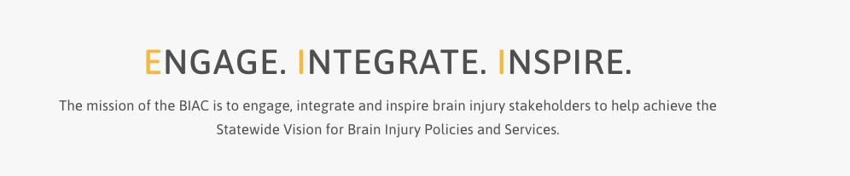
Brain Injury Advisory Council (BIAC) Meeting

June 12, 2026 - 10:00 a.m. – 2:00 p.m. CT

Zoom information for connecting: https://educationne.zoom.us/j/94166263913

To Join By Phone, dial +1 312 626 6799 US (Chicago) - Meeting ID: 941 6626 3913
Find your local number: https://educationne.zoom.us/u/avQempuQZ

AGENDA

10:00 – 10:15 am: ENGAGE
Call the meeting to order – Council Chair, Emaly Ball
Please enter your name in the chat box so the Recorder can take attendance and determine a quorum. We ask that you join the meeting with your camera on, if possible, and keep your microphone or telephone muted if you are not speaking to reduce background noise.

Approve March 13, 2026 meeting minutes and June 12, 2026 meeting agenda – Council Chair, Emaly Ball
BIAC members, please read the past meeting minutes and the new agenda before the meeting and be prepared to offer any corrections to the minutes or additions to the agenda if needed. Vote to approve.

10:15 – 10:45 am: INSPIRE
Draft TBI grant goals and objectives for next cycle– Keri Bennett, Nebraska VR
Keri will discuss the next TBI grant cycle goals and objectives. Member questions and discussion are welcome. Proposed goals and objectives are subject to change when the grant application is released, but your vote of initial support is requested.

10:45 – 11:00 am – Break

11:00 am – 12:30 pm: ENGAGE
Nebraska Medicaid Work Requirements – Celia Wightman, Marketing & Communications Specialist, and Drew Preston DHHS Program Specialist, with Medicaid & Long-Term Care, Nebraska Department of Health and Human Services
Celia and Drew will give a presentation on the new Nebraska Medicaid Work Requirements and Exemptions. No member action is needed, but there will be time for questions.
12:30 – 12:50 pm: Working Lunch
Break for lunch for 20 minutes. Please feel free to bring your meal back to the meeting as we continue to work through our agenda.

12:50 – 1:30 pm: ENGAGE AND INTEGRATE
Lifespan Respite Care - Hanna Quiring, Policy Administrator and Daniel Petersen, SHCN Program Coordinator with Developmental Disabilities, Home and Community-Based Services & Special Health Care Needs, Nebraska Department of Health and Human Services
Hanna and Dan will present on the Lifespan Respite Care program. No member action is needed, but there will be time for questions.

1:30 am – 1:40 pm - Updates: ENGAGE
Committee and Contractor Reports (written reports)
Please review the written reports and be prepared with any questions or comments for the Committee Chairpersons.

Public Policy – (oral report) - Tiffany Armstrong
No report on this quarter. No member action is needed, but there will be time for questions.

Membership – (no report) – Carla Lasley
No report this quarter. No member action is needed, but there will be time for questions.

Contractor reports and ACL Workgroup Updates (written report only) – Keri Bennett
Please review the written reports. No member action is needed, but there will be time for questions.

1:40 – 2:00 pm: ENGAGE, INTEGRATE AND INSPIRE

Unfinished (Old) Business (if any)
If there are questions regarding past BIAC business items that were unresolved, you may raise them here.

Roundtable Discussion: All Members
Members are invited to share updates or new information on what their organization, agency, or representative population is doing related to brain injury.

New Business (if any)
If you have a new topic or issue you believe the BIAC should consider, you may raise it here and request it be added to a future meeting agenda.

Adjourn – Please complete our survey at the end of the meeting. Your feedback helps the BIAC leadership continue to improve your member experience. Thank you!

Feel free to stay on for the “Parking Lot” after the meeting adjourns!

Next Meeting Date: September 11, 2026

