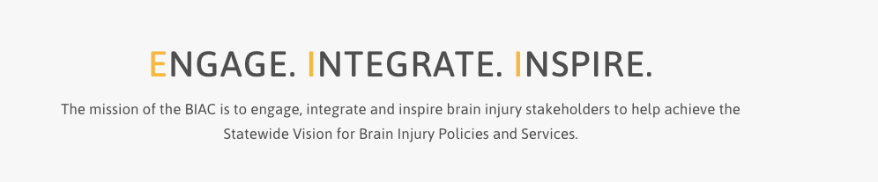

**Brain Injury Advisory Council (BIAC) Meeting**

**March 28, 2025 - 10:00 a.m. – 2:00 p.m. CT**

**Zoom information for connecting:** <https://educationne.zoom.us/j/94166263913>

     To Join By Phone, dial +1 312 626 6799 US (Chicago) - Meeting ID: 941 6626 3913

Find your local number: [https://educationne.zoom.us/u/avQempuQZ](https://gcc02.safelinks.protection.outlook.com/?url=https%3A%2F%2Feducationne.zoom.us%2Fu%2FavQempuQZ&data=04%7C01%7Ctresa.christensen%40nebraska.gov%7C8eda94b598aa45b8998c08d8de701be1%7C043207dfe6894bf6902001038f11f0b1%7C0%7C0%7C637503921589608306%7CUnknown%7CTWFpbGZsb3d8eyJWIjoiMC4wLjAwMDAiLCJQIjoiV2luMzIiLCJBTiI6Ik1haWwiLCJXVCI6Mn0%3D%7C1000&sdata=T9GyKObyOhtXev7WvsMZvUHeowOIFrkAK9DKWLQkB0s%3D&reserved=0)

**AGENDA**

**10:00 – 10:30 am:** ***ENGAGE***

**Call the meeting to order – *Council Chair, Emaly Ball***

*Please enter your name in the chat box so the Recorder can take attendance and determine a quorum. We ask that you join the meeting with your camera on, if possible, and keep your microphone or telephone muted if you’re not speaking to reduce background noise.*

**Introductions*****–Emaly Ball and all members***

*Emaly will introduce our new members, Jessica Coffey and Kristen Larsen, and all members will briefly introduce themselves.*

**Approve December 13, 2024 meeting minutes and March 28, 2025 meeting agenda – *Emaly Ball***

*BIAC members, please read the past meeting minutes and the new agenda before the meeting and be prepared to offer any corrections to the minutes or additions to the agenda if needed. Vote to approve.*

**Annual Council member Conflict/Duality of Interest Declarations – *Keri Bennett***

*Review the Conflict/Duality of Interest policy in Article IV. of the Operating Procedures and be prepared to declare any conflict/duality of interest.*

**10:30 – 10:45 am: *ENGAGE and INTEGRATE***

**2024 Needs Assessment Final Report Overview** **–*Liz Gebhart-Morgan of Partners for Insightful Evaluation (PIE)***

*Liz will give a brief overview of the final 2024 Needs Assessment report. No member action is needed, but there will be time for questions.*

**10:45 – 10:55 am – Break**

**10:55 – 11:40 am: *ENGAGE and INTEGRATE***

**TARC State Self-Assessment Tool** – **Advisory Boards -** ***Keri Bennett***

*Keri will present on the Advisory Board Tool and then we’ll join breakout rooms for 15 minutes for small group discussion. Please choose a person in your group to take notes. Each group will then report out to the large group. The small group discussion questions are: 1. How well does our Council represent* ***all*** *Nebraskans with brain injury? Are there any groups who need better representation? 2. What other connections or activities could the Council pursue to give people with brain injury and their families a louder voice?*

**11:40 am – 12:00 pm:**

**Working Lunch**

*Break for lunch for 20 minutes. Please feel free to bring your meal back to the meeting as we continue to work through our agenda.*

**12:00 – 12:20 pm:**

**My Brain, My Self Pilot Evaluation Report** – ***Liz Gebhart-Morgan of Partners for Insightful Evaluation (PIE)***

*Liz will briefly present on the My Brain, My Self Pilot Evaluation report. No member action is needed, but there will be time for questions.*

**12:20 – 12:30:**

**BI State Plan** - ***Keri Bennett***

*Keri will offer a recommendation to move to a 5-year state plan. Members will vote to approve\disapprove.*

**12:30 – 12:40 pm: *ENGAGE and INTEGRATE***

**ABI Peer to Peer Support RFP** – ***Keri Bennett***

*Keri will share background information on the ABI Peer to Peer Support RFP that will be released March 31, 2025. No member action is needed, but there will be time for questions.*

**12:40 – 12:55 pm: *INSPIRE***

**Online Brain Injury Screening and Support System (OBISSS) and Remove/Reduce, Educate, Adjust/Accommodate, Pace (REAP)** – ***Peggy Reisher – BIA-NE***

*Peggy will give presentations on OBISSS and REAP - No member action is needed, but there will be time for questions.*

**12:55 – 1:05 pm:**

**Brain Injury Awareness Events in Washington, DC** - ***Peggy Reisher, BIA-NE and Keri Bennett, NE VR***

*Peggy and Keri will give brief reports about the BI Awareness events they attended in Washington D.C. No member action is needed, but there will be time for questions.*

**1:05 – 1:30 pm - Updates: *ENGAGE and INSPIRE***

**Committee and Contractor Reports (written reports)**

*Please read the written reports and be prepared with any questions or comments for the Committee Chairpersons.*

**Public Policy** – ***Tiffany Armstrong***

*Tiffany will discuss the updates on the current bill trackers and proposed changes to the process. Members will vote to approve/disapprove the process changes,.*

**Membership****– (written report only) *– Carla Lasley***

*Please review the written report. No member action is needed, but there will be time for questions.*

**Contractor reports and ACL Workgroup Updates (written reports only) – *Keri Bennett***

*Please review the written reports. No member action is needed, but there will be time for questions.*

**1:30 – 2:00 pm: *ENGAGE and INSPIRE***

**Roundtable Discussion:** ***All Members***

**Unfinished (Old) Business** (if any)

*If there are questions regarding past BIAC business items that were unresolved, you may raise them here.*

**New Business** (if any)

*If you have a new topic or issue you believe the BIAC should consider, you may raise it here and request it be added to a future meeting agenda.*

**Stay Interviews** – ***Emaly Ball***

*Emaly will present to the members the concept of a stay interview.*

**Adjourn – Please complete our survey at the end of the meeting. Your feedback helps the BIAC leadership continue to improve your member experience. Thank you!**

**Feel free to stay on for the “Parking Lot” after the meeting adjourns!**

**Next Meeting Date**: June 13, 2025